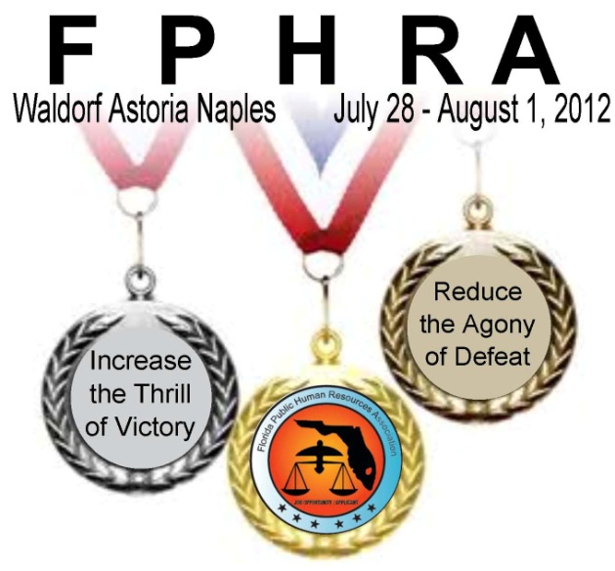
FPHRA’s 2012 Annual
Conference
Registration continues!

Rooms at the Waldorf Astoria Naples that are blocked off for the conference attendees are already more than half gone!!
Get on the Team and get your registration and reservations in!
An outstanding conference is coming soon, where the best of the best HR athletes will enjoy dynamic public sector Human Resources educational sessions, fun and productive networking events and an exhibit hall that highlights vendors from all areas of the public Human Resources arena. The conference is the forum for all levels of HR in the public sector and is the only conference in the State of Florida that is dedicated to public sector HR professionals.
The Pre-Conference will be all day Saturday, July 28th and Sunday morning, July 29th. This year’s outstanding pre-conference line-up includes the “FPHRA Academy” for professionals entering public sector HR or that are interested in a refresher, “Pay and Classification”, and a return of the popular “Master’s Program”.

The general Conference kicks off with the President’s Welcome Reception Sunday evening and concludes at noon on Wednesday August 1. The Executive Board is diligently working to offer some excellent HR topics such as FLSA, FMLA, Background Checks, Legislative Update, Legal Update, Pension Plans, Health Care, etc. Be sure to watch for updates to the schedule. And each evening, make sure to join the Winner’s Circle, also known as the Hospitality Suite, for the nightly medal ceremony and networking opportunities!

You will also enjoy great meals and entertainment, refreshment breaks and an Olympic themed dinner/dance. You will be awed by the beauty of the resort and one of the best of Florida’s beaches.
Registration for the Pre-Conference prior to June 22 is $90 for members and $140 for non-members. Conference Registration is only $275 prior to June 22 for members and $325 for non-members (and includes membership for the remainder of year). Plan now to enjoy the beautiful area and wonderful public HR knowledge at FPHRA's 2012 Annual Conference in Naples!
To learn more about FPHRA's Annual Conference or to register, visit the FPHRA website and click on the 2012 Annual Conference link (or click here).

The Conference at a Glance and the Pre-Conference Agenda are now available and attached!

Remember to Reserve Your Room Early this Year!
The room block at the Waldorf Astoria Naples is more than half gone!
Don’t miss the chance to stay at the Waldorf Astoria Naples while enjoying the exceptional educational sessions and peer-to-peer networking with other professionals that you have come to expect from this exceptional experience!
Make your hotel reservations by contacting the Waldorf Astoria, Naples at 1-800-445-8667 and letting them know you are attending the FPHRA conference. For more information about the resort, visit their website at www.waldorfastorianaples.com. Conference room rates are $149.00 per night and there is no charge for self parking and no resort fee – be sure to state that you are staying for the FPHRA conference.

Volunteers for the conference are needed! Make the conference even more enjoyable and increase your networking by volunteering. Whether it’s 1 hour to moderate a session or 1 day of manual labor, we have a place for you to be a part of the team that makes the conference a success! For more information or to volunteer, contact Andy Brooks, abrooks@casselberry.org or 407-262-7700 x1150.

Sponsorship opportunities are available! Learn more about FPHRA's sponsorships by visiting the FPHRA-Sponsors website or contact Lydia Storck, Host Committee, at 813-274-8563 or Lydia.Storck@ci.tampa.fl.us for further information. Please note there are a limited number of sponsorships available.
Exhibitor opportunities are available! Learn more about FPHRA's opportunities for exhibitors by visiting the FPHRA-Exhibitors website or contact Lydia Storck, Host Committee, at 813-274-8563 or Lydia.Storck@ci.tampa.fl.us for further information

If you have any questions regarding the conference, please contact
Andy Brooks, Host Committee Chair at abrooks@casselberry.org or 321-363-6625;
or Joe Denaro, FPHRA President at 321-383-5820.

